**Output:**

Open Nmap - Zenmap GUI

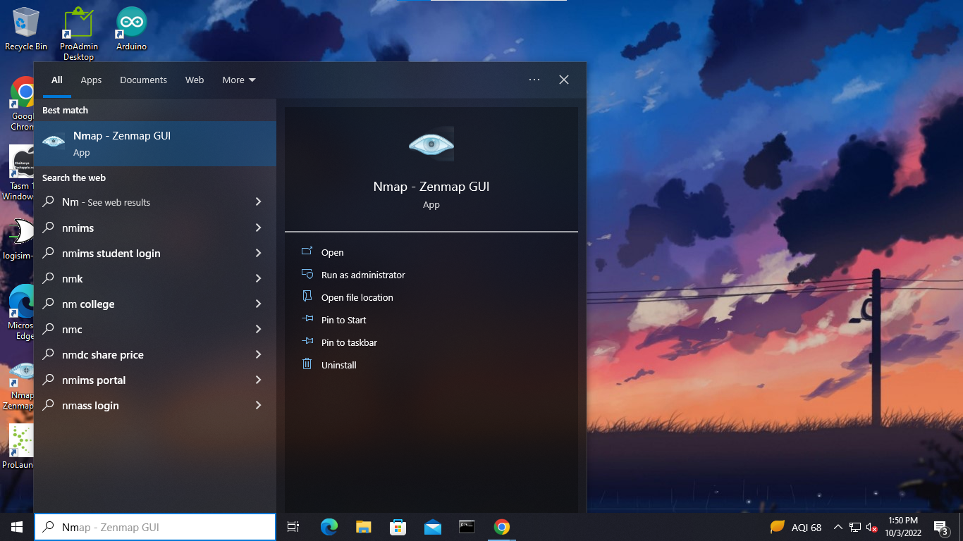

Download WinSCP

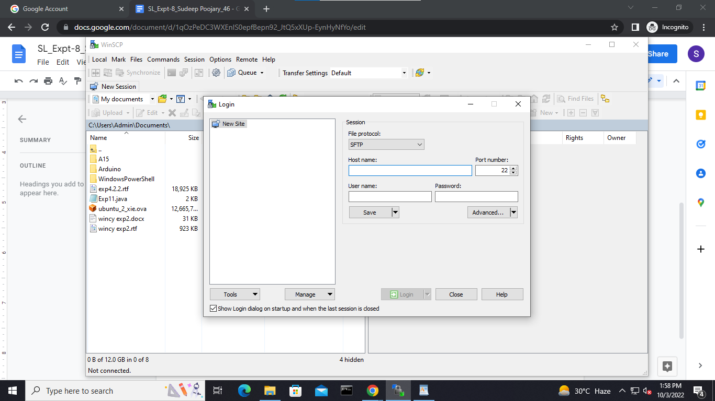

**Website Crawling:**

1. Open a Terminal windows
2. To install Apache, install the latest meta-package apache2 by running o sudo apt update

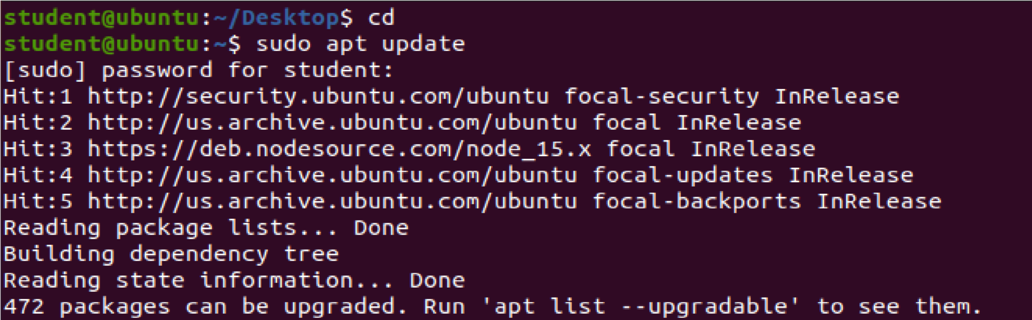

o

sudo apt install apache2

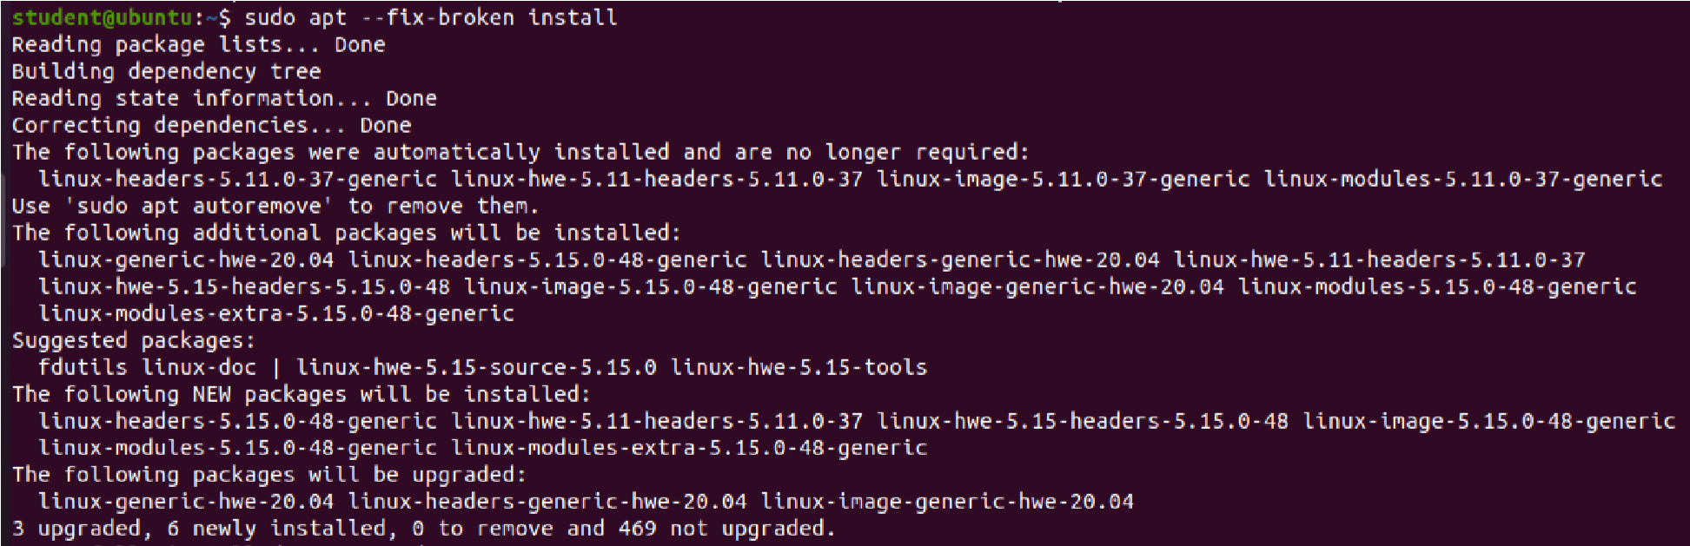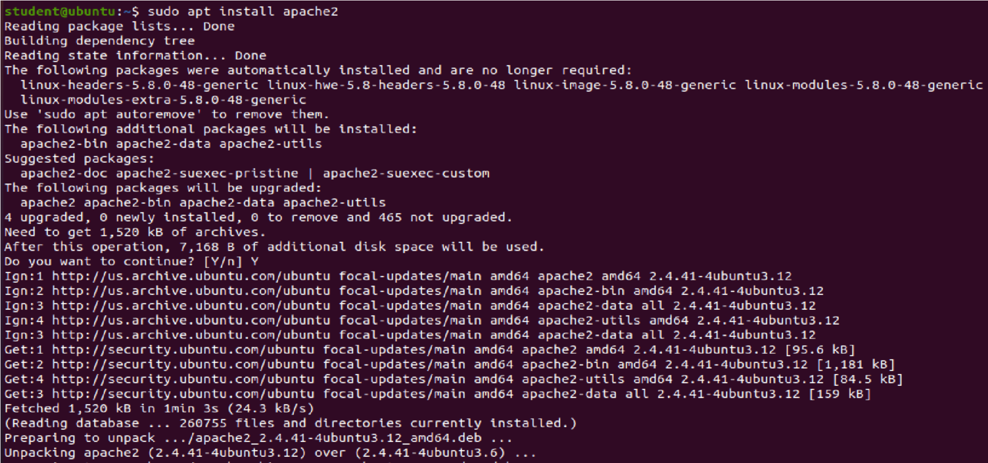

After letting the command run, all required packages are installed and we can test it out by typing in our IP address for the web server.

**Replace the default website:**

1. In order to replace the default website we will need to have root access over SSH for file transfer. By default, SSH on Ubuntu configured in a way that disables the root user login, this was originally enabled as a security precaution which means that you cannot directly log in as the root user over SSH.

To enable root login directly over SSH in Ubuntu we will need to reset the root password, configure SSH to allow root login and restart the SSH service.

Open a terminal and type following command for reset/set root password.

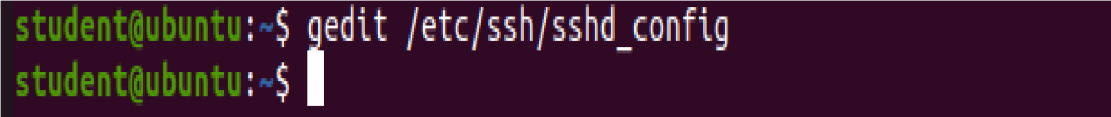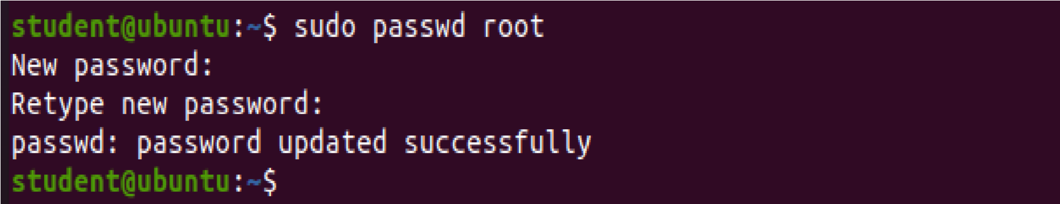

Configure SSH config to permit root login

Edit /etc/ssh/sshd_config file with following command.

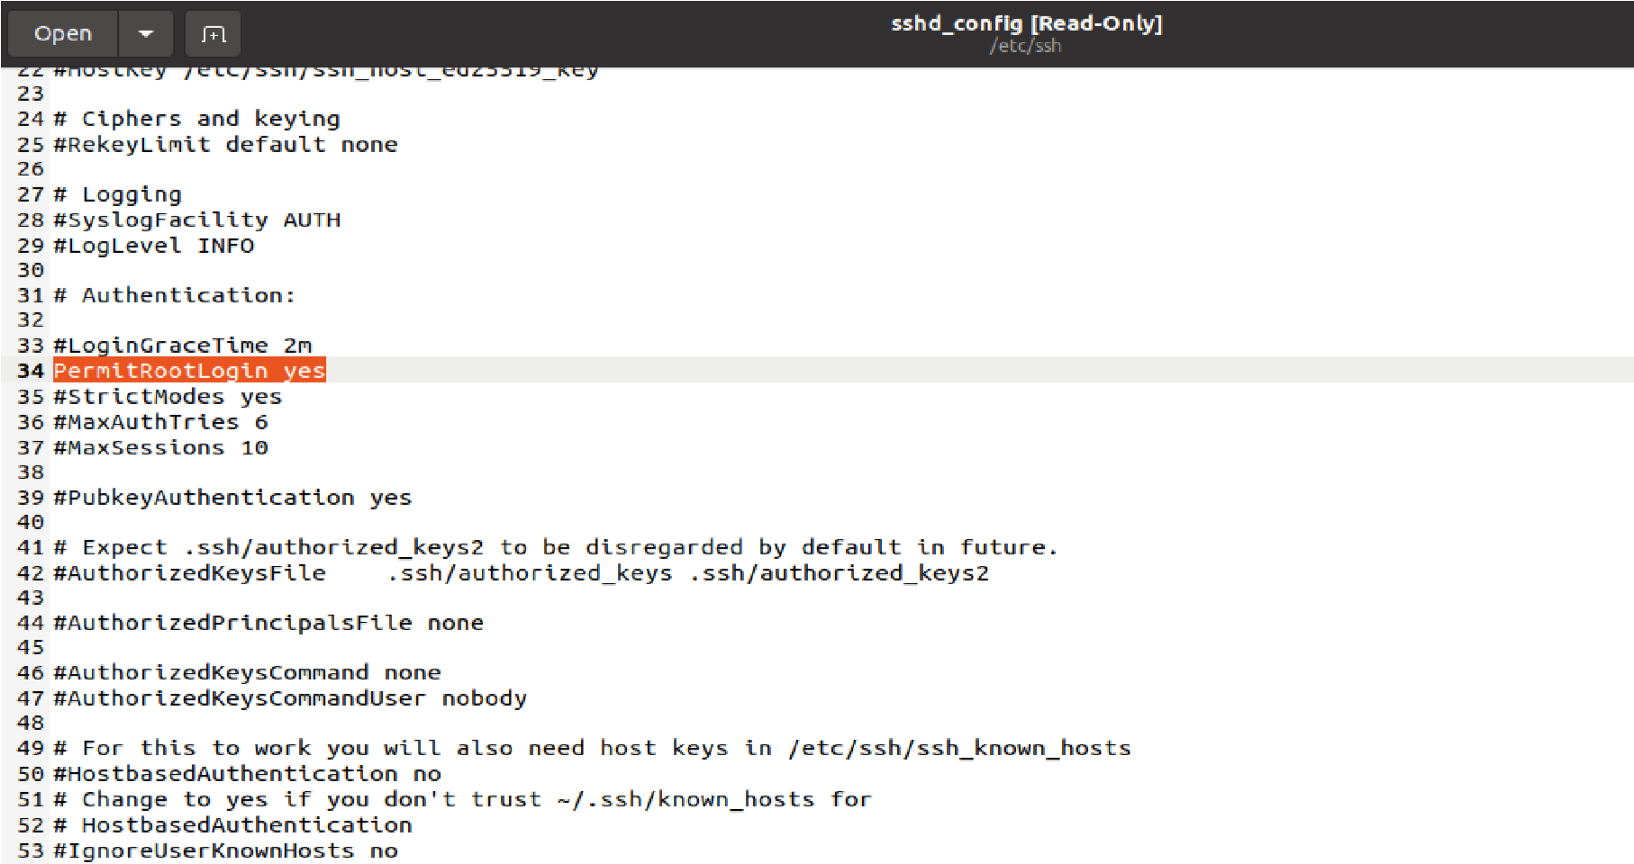

As you see, the PermitRootLogin is set to No. It means that the root login via SSH has been disabled. So, to enable root login change the No to Yes. Find PermitRootLogin and delete No or without-password and type yes. After edit the SSH config file, press Ctrl + x and press Enter button twice for save and exit.

Restart SSH service for loading new configuration on SSH_config file.



1. Download and install WinSCP given in the local network folder (app to file transfer between a local and a remote [Linux] computer)

Download the website zip file and extract it to /var/www/html

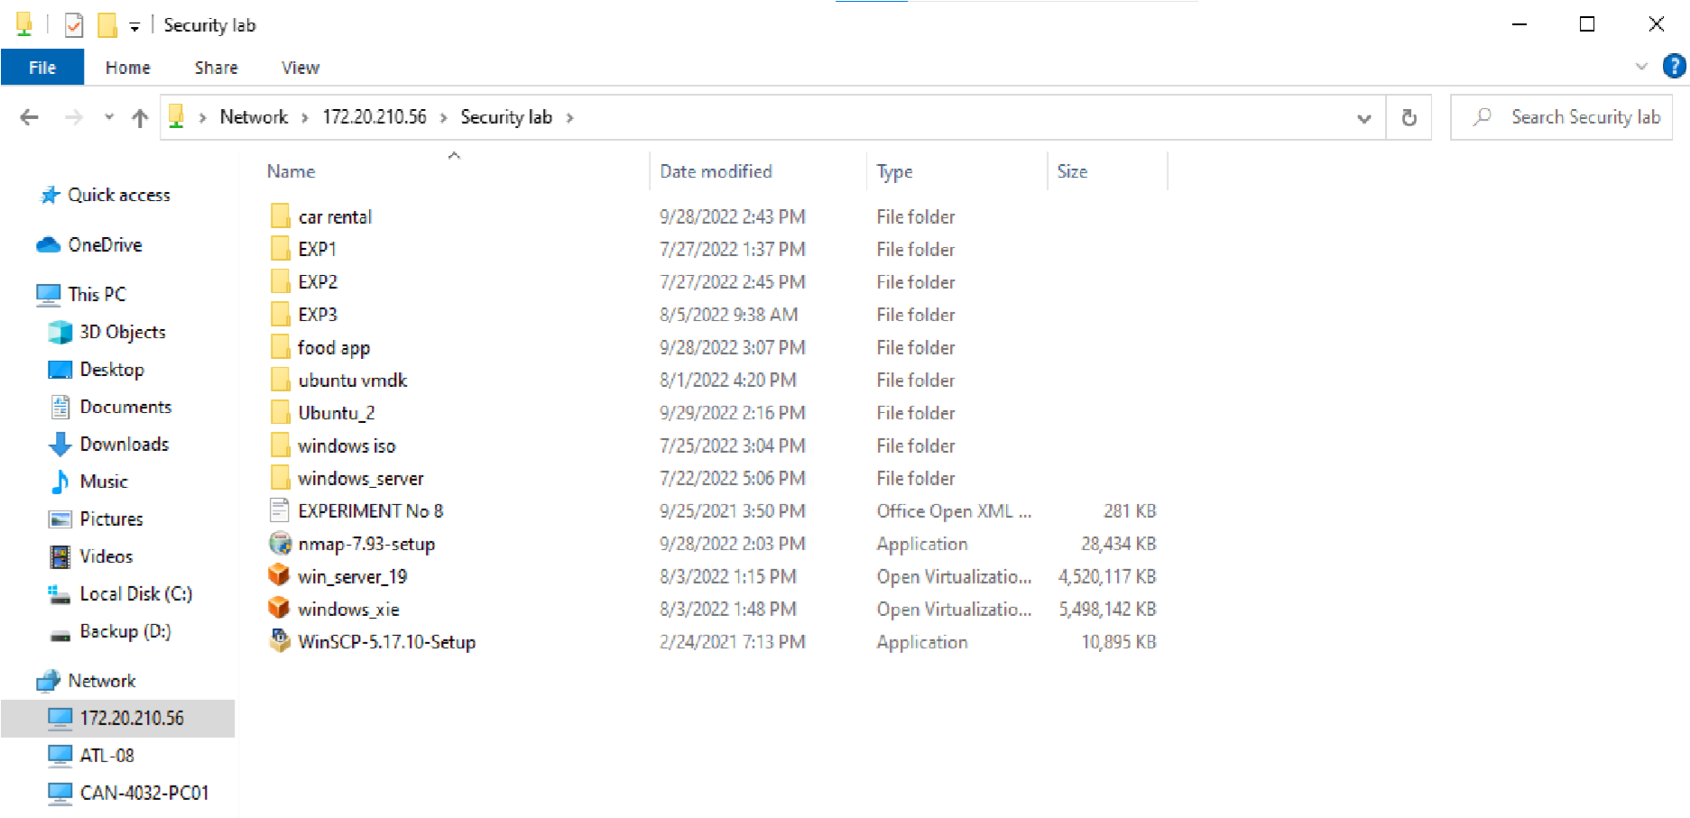

1. Close any open browser and browse to the Linux VM IP address.

4.

Enter the above IP Address in Firefox and check the result i.e., a Food Application

This is the required result

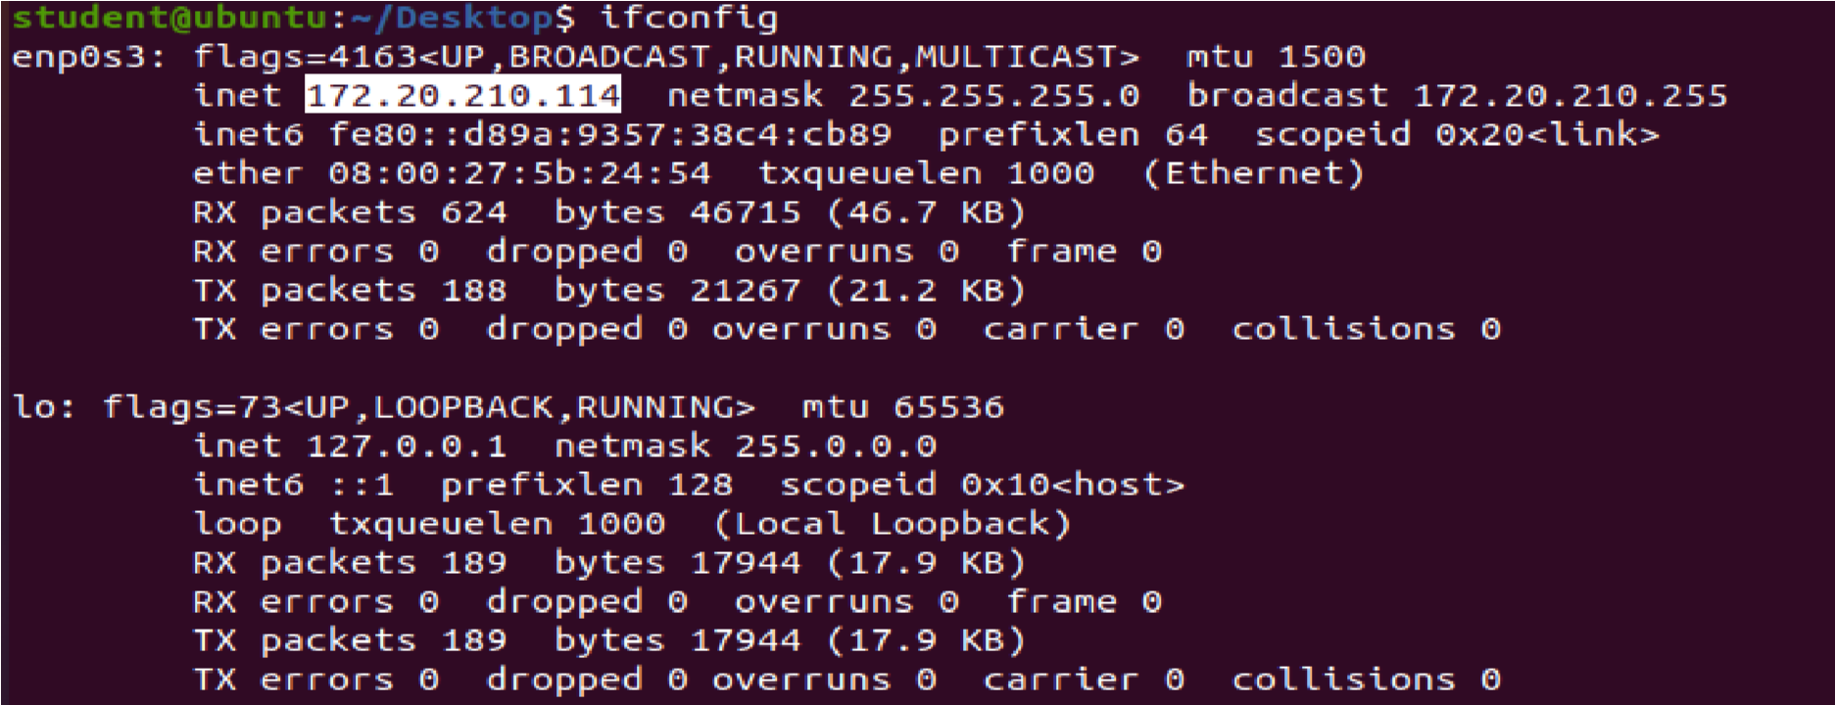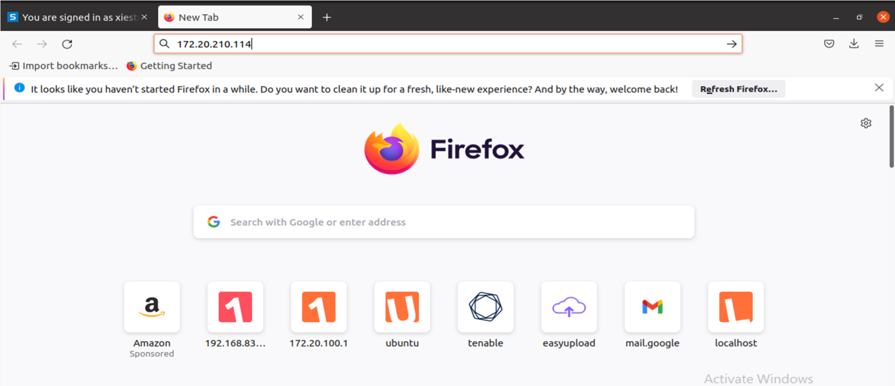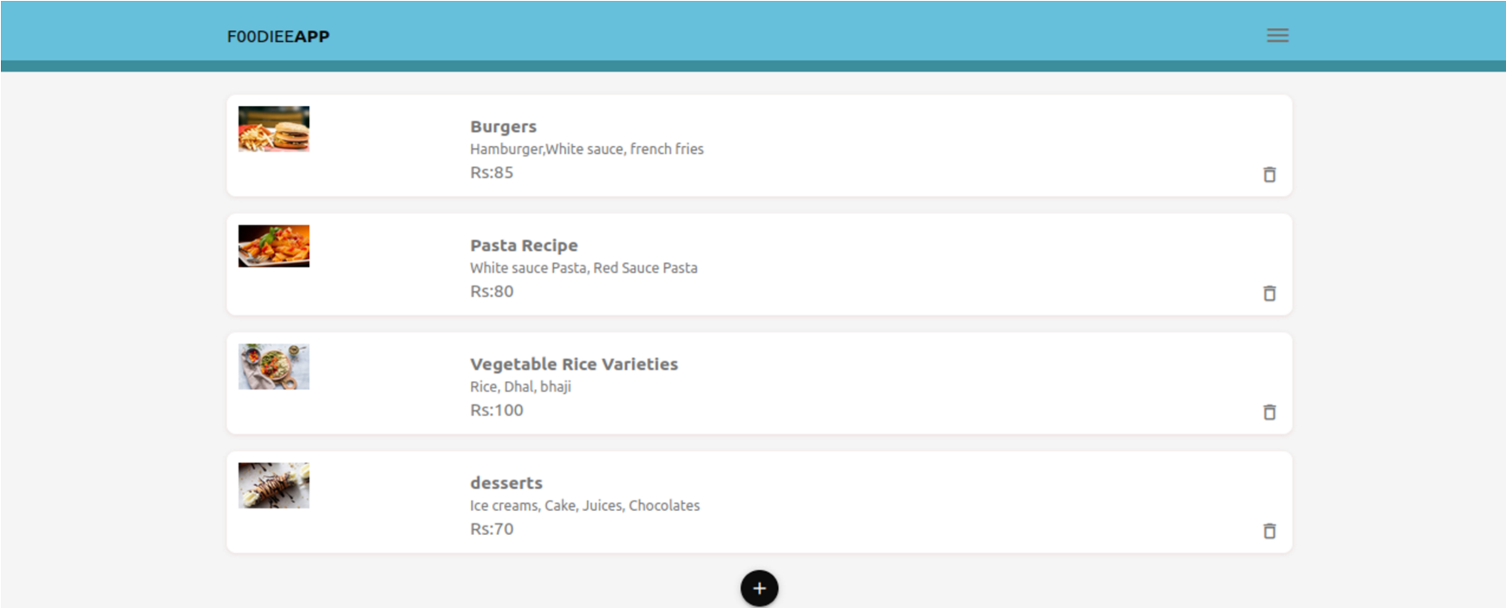

5. Now enter your IP Address, Username and Password of Ubuntu in **WinSCP** inorder to connect with Ubuntu so that we can copy the files from Windows to Ubuntu

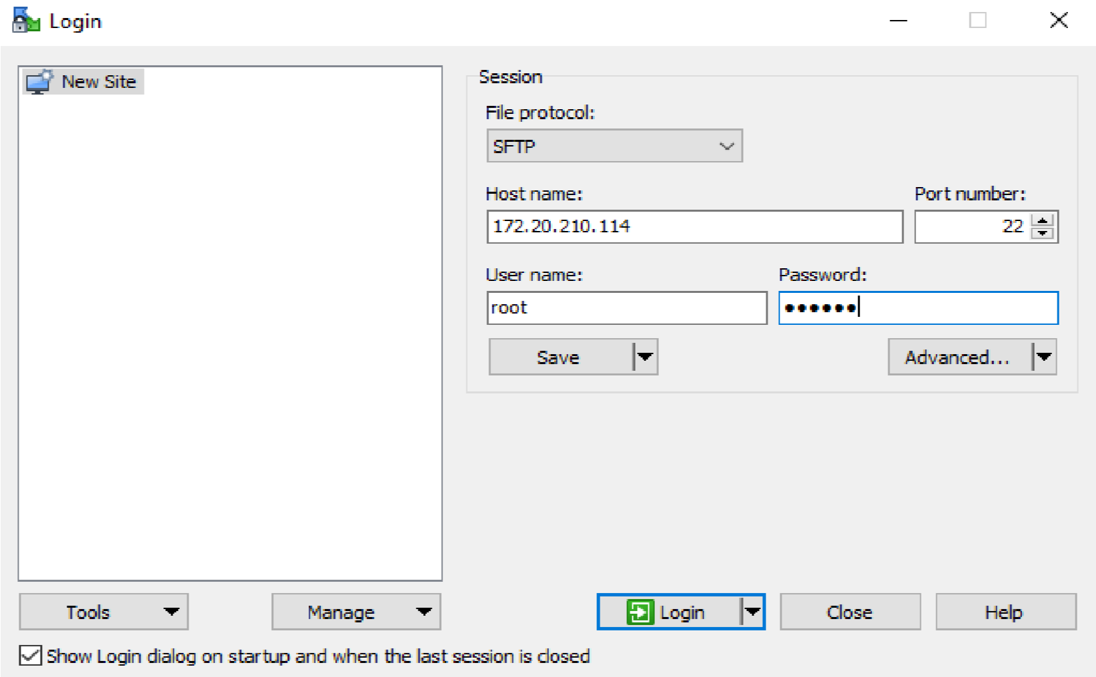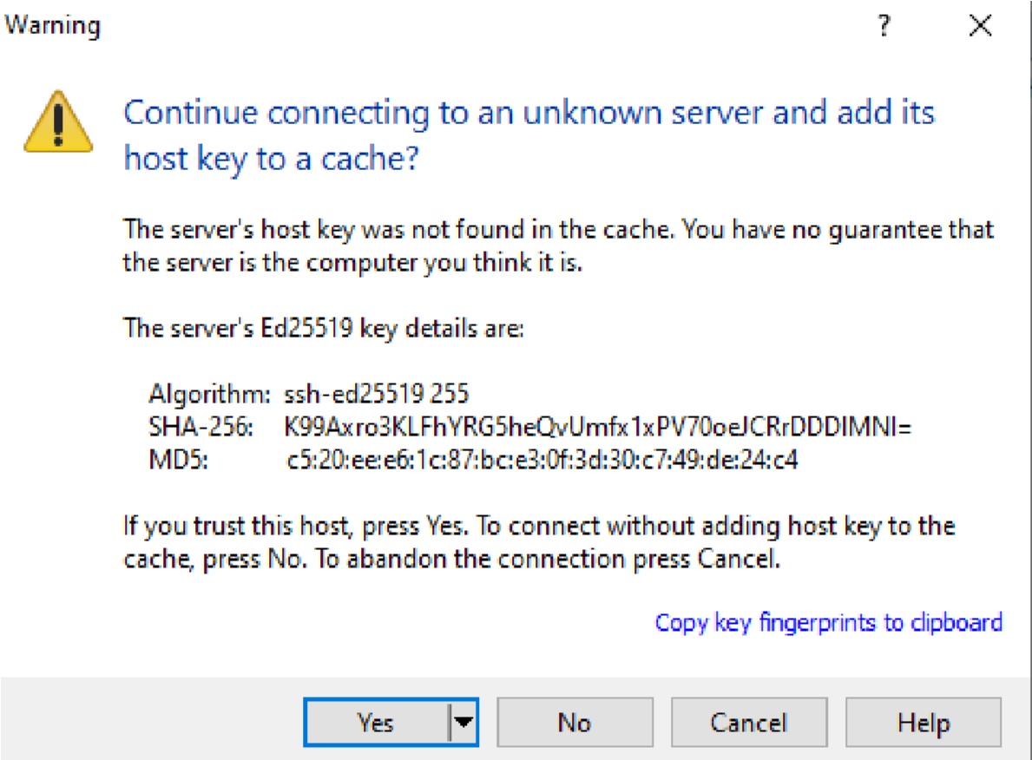

6.

Coping all the selected file from windows to ubuntu

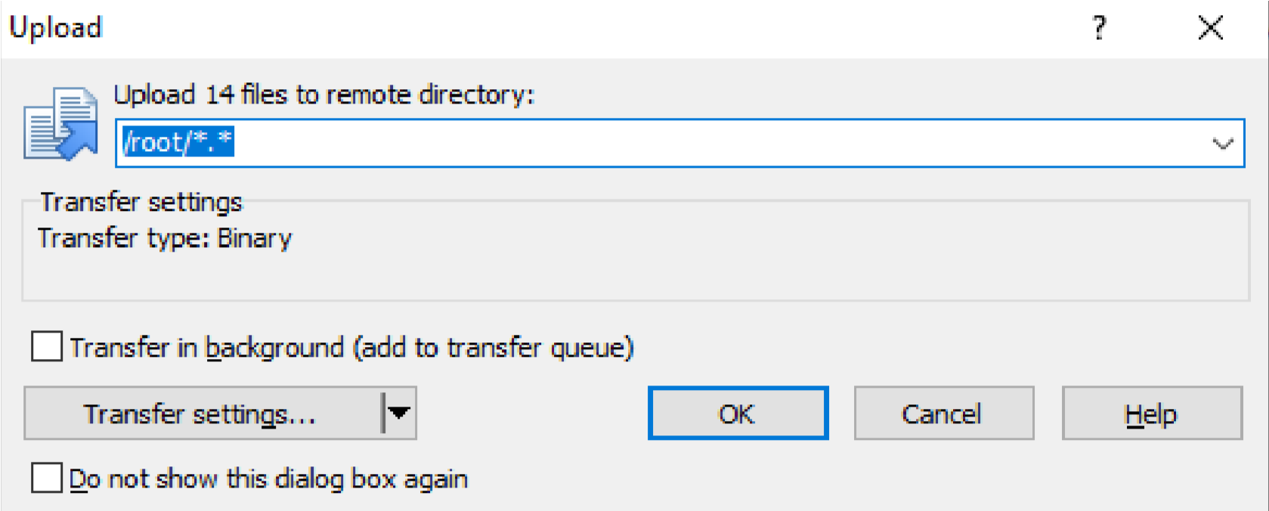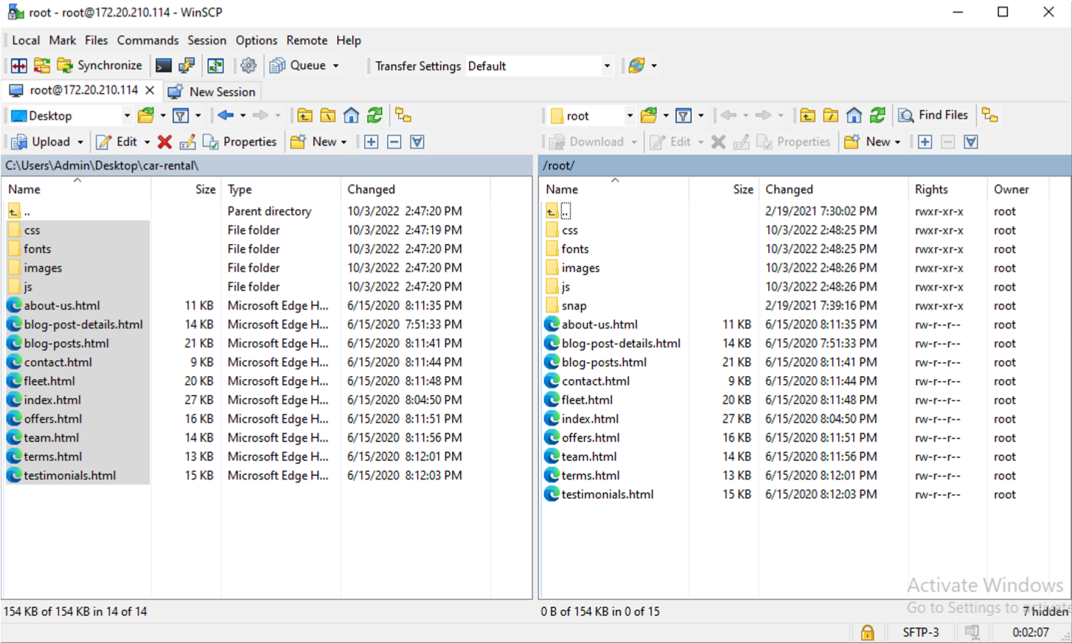

1. Now enter your IP Address i.e. 172.20.210.114 again in Firefox to check the changes i.e., the Food Application is now changed to Car Rental Website

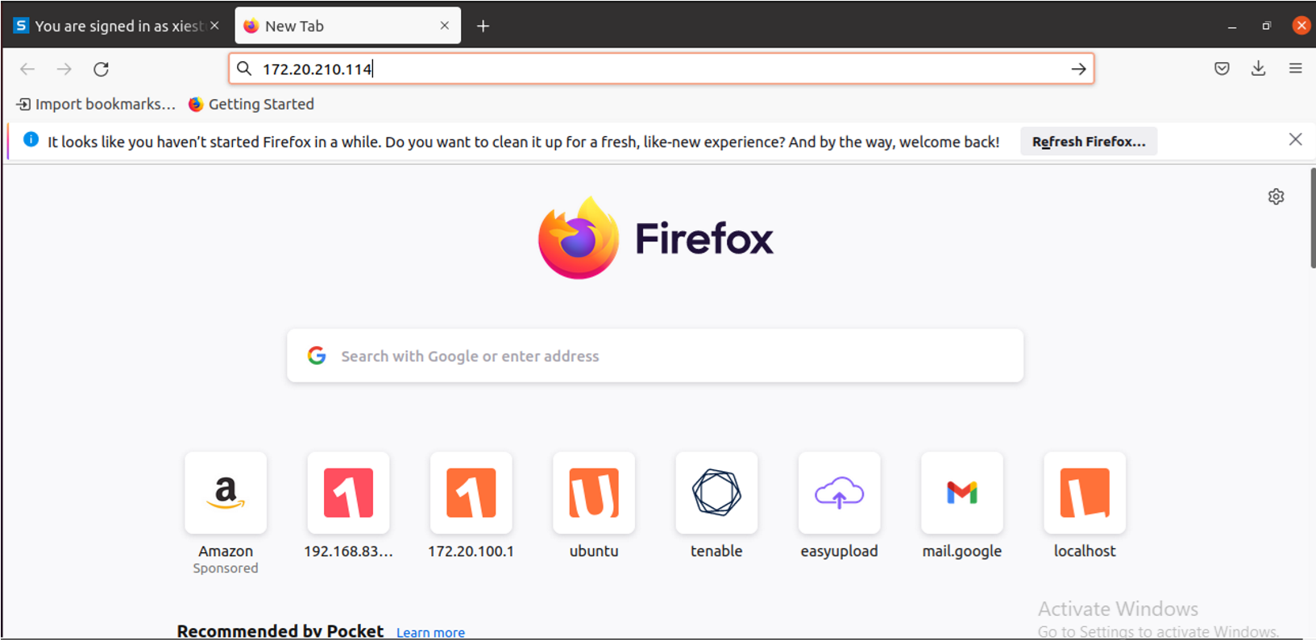

1. you get the Website means you have done the website crawling.

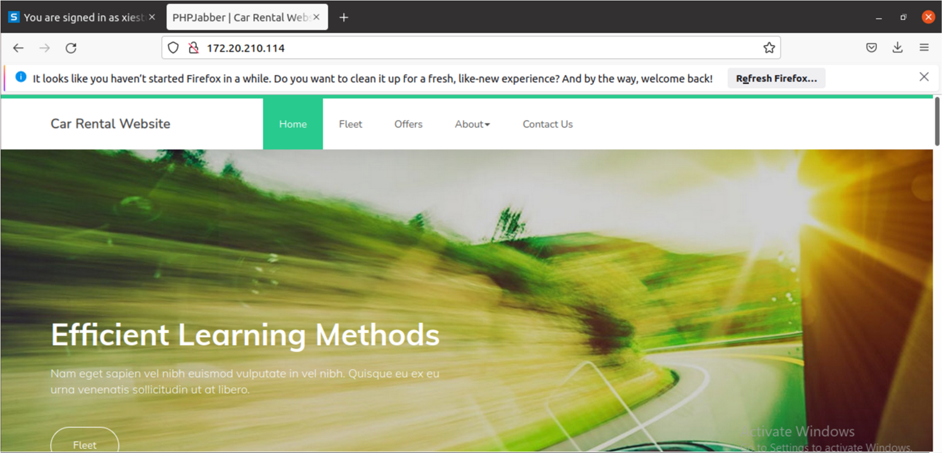

1. Now download and open Nmap-Zenmap GUI

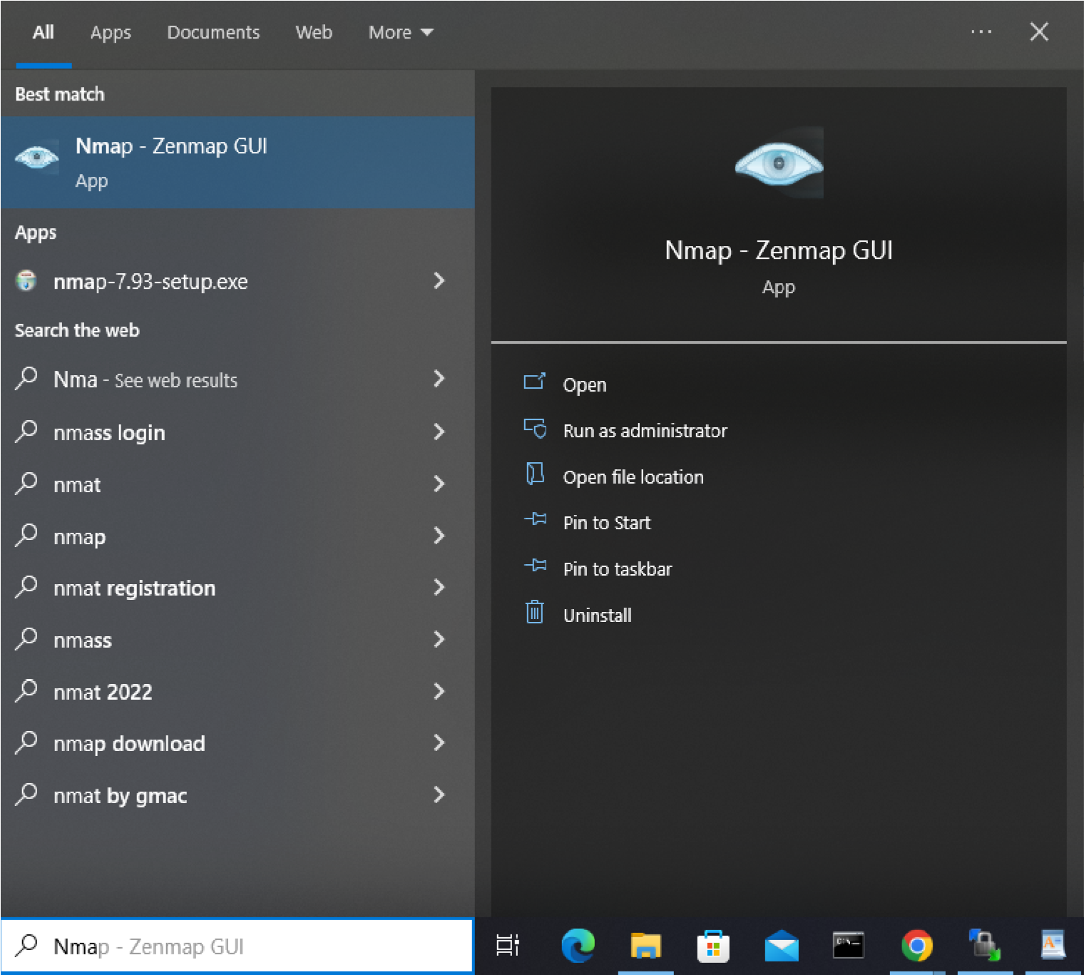

10.

Enter the IP Address of the PC next to you or any other PC

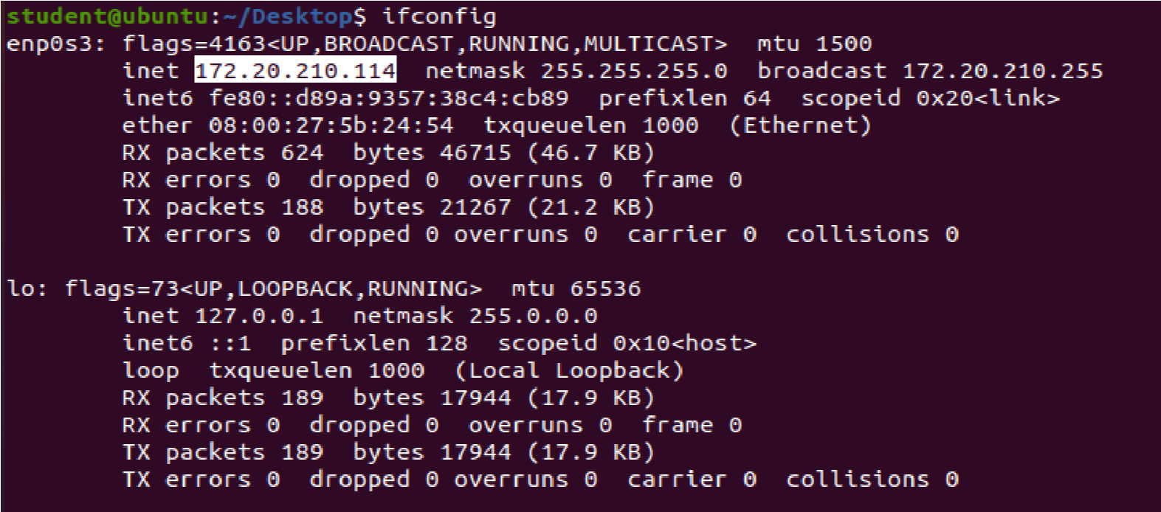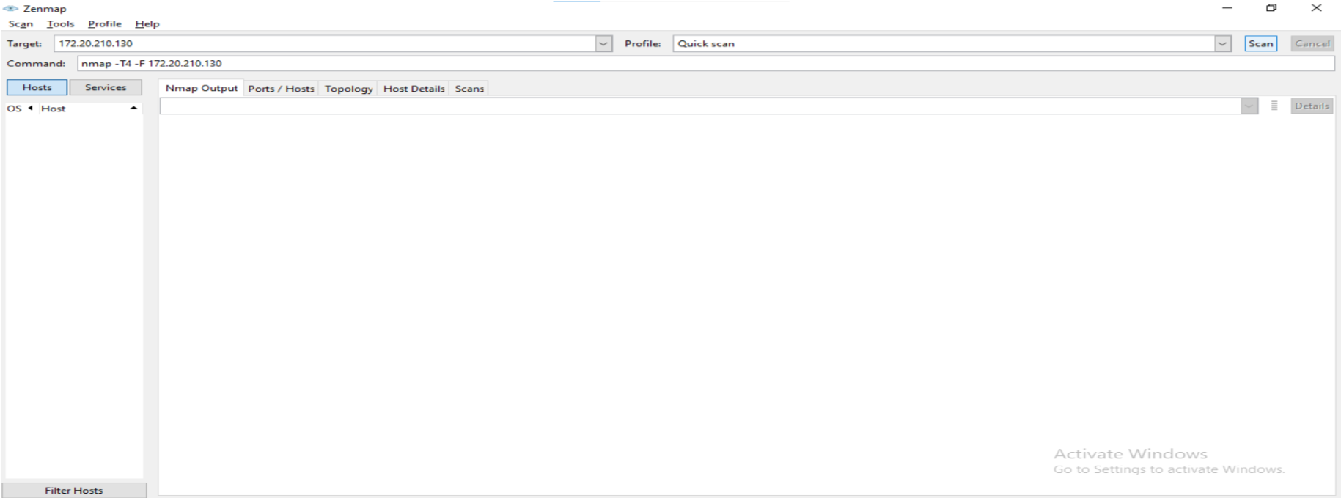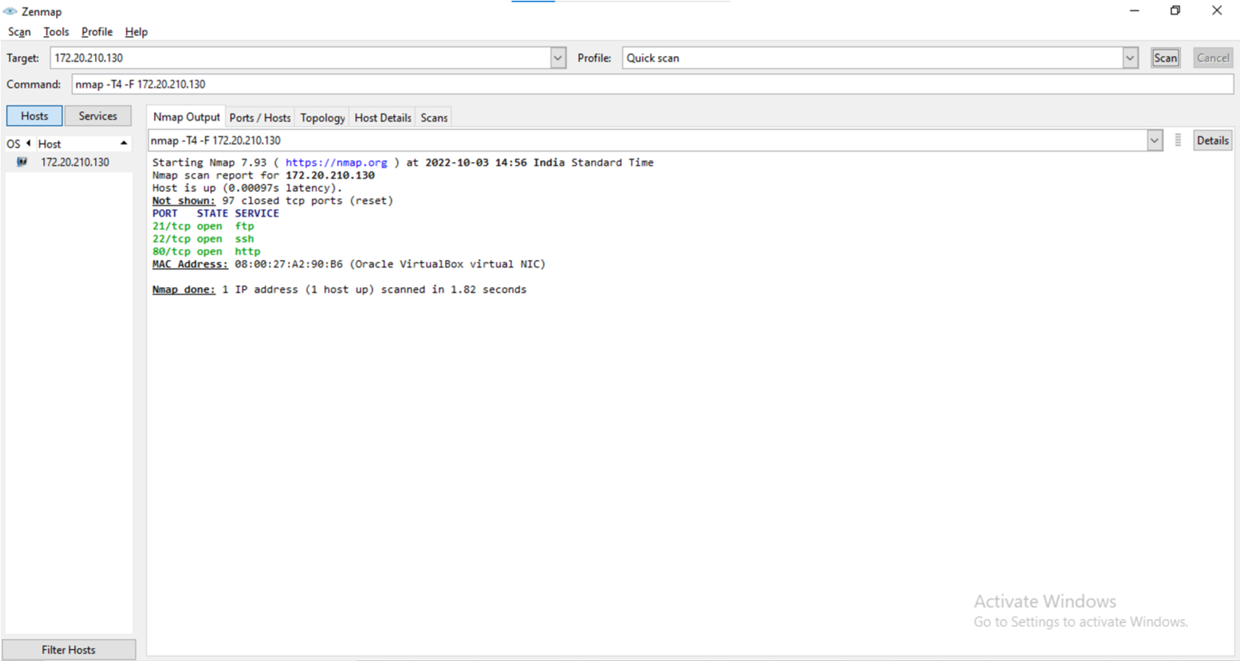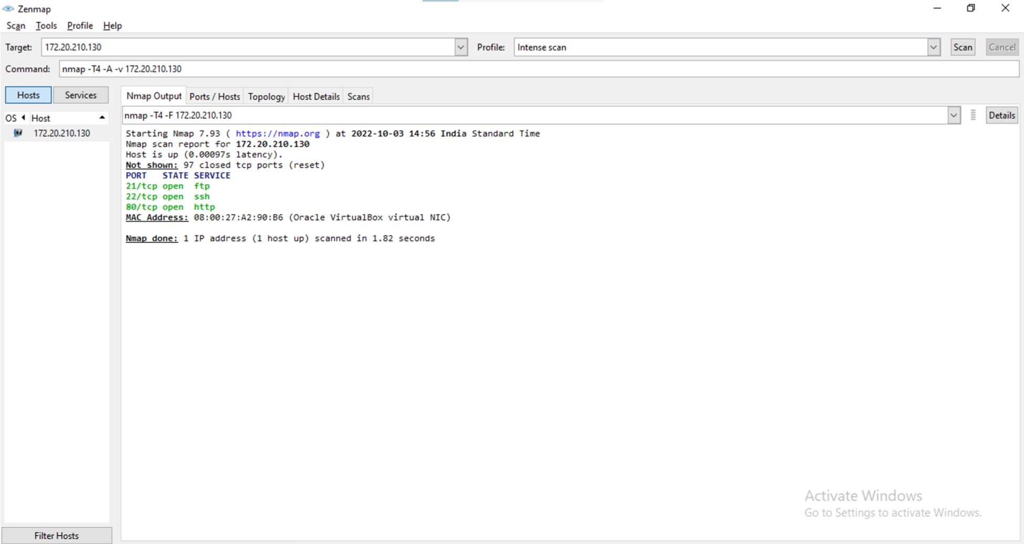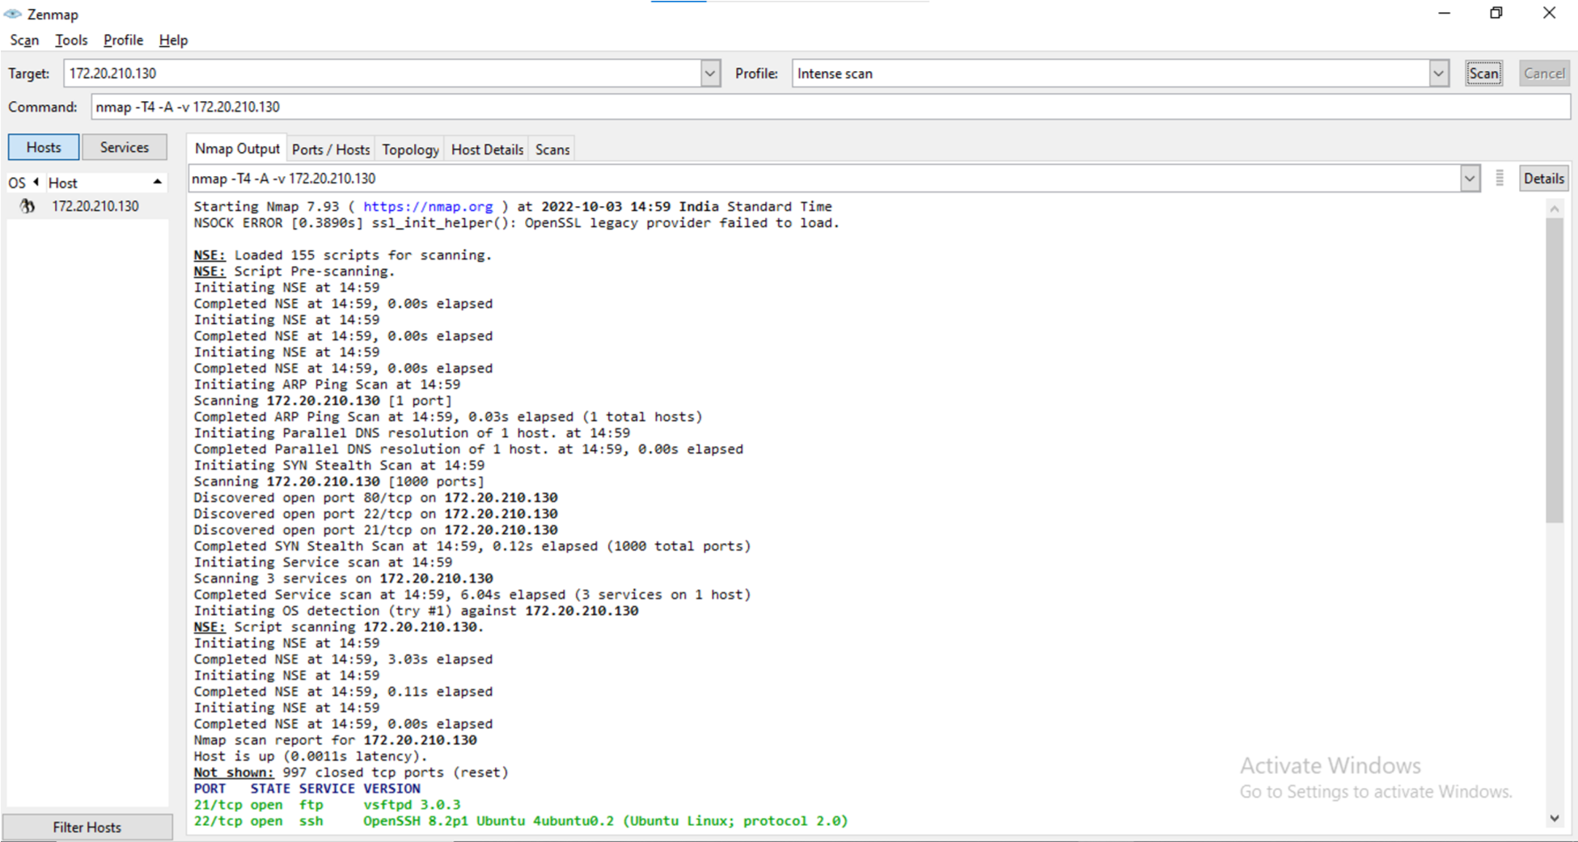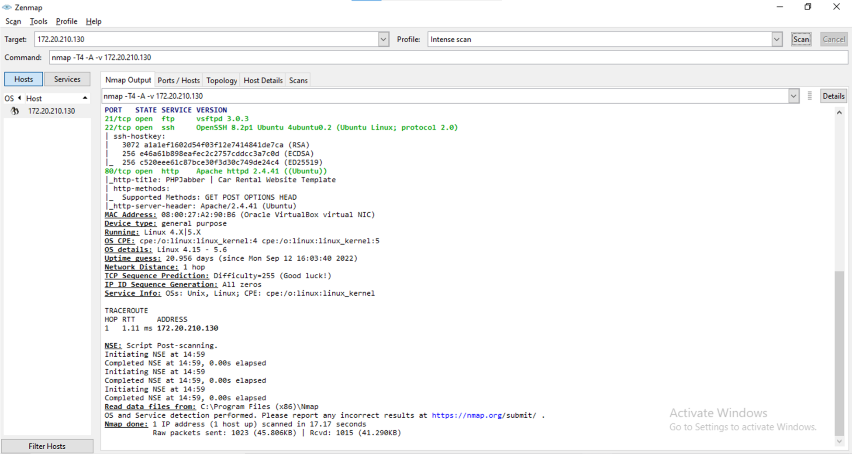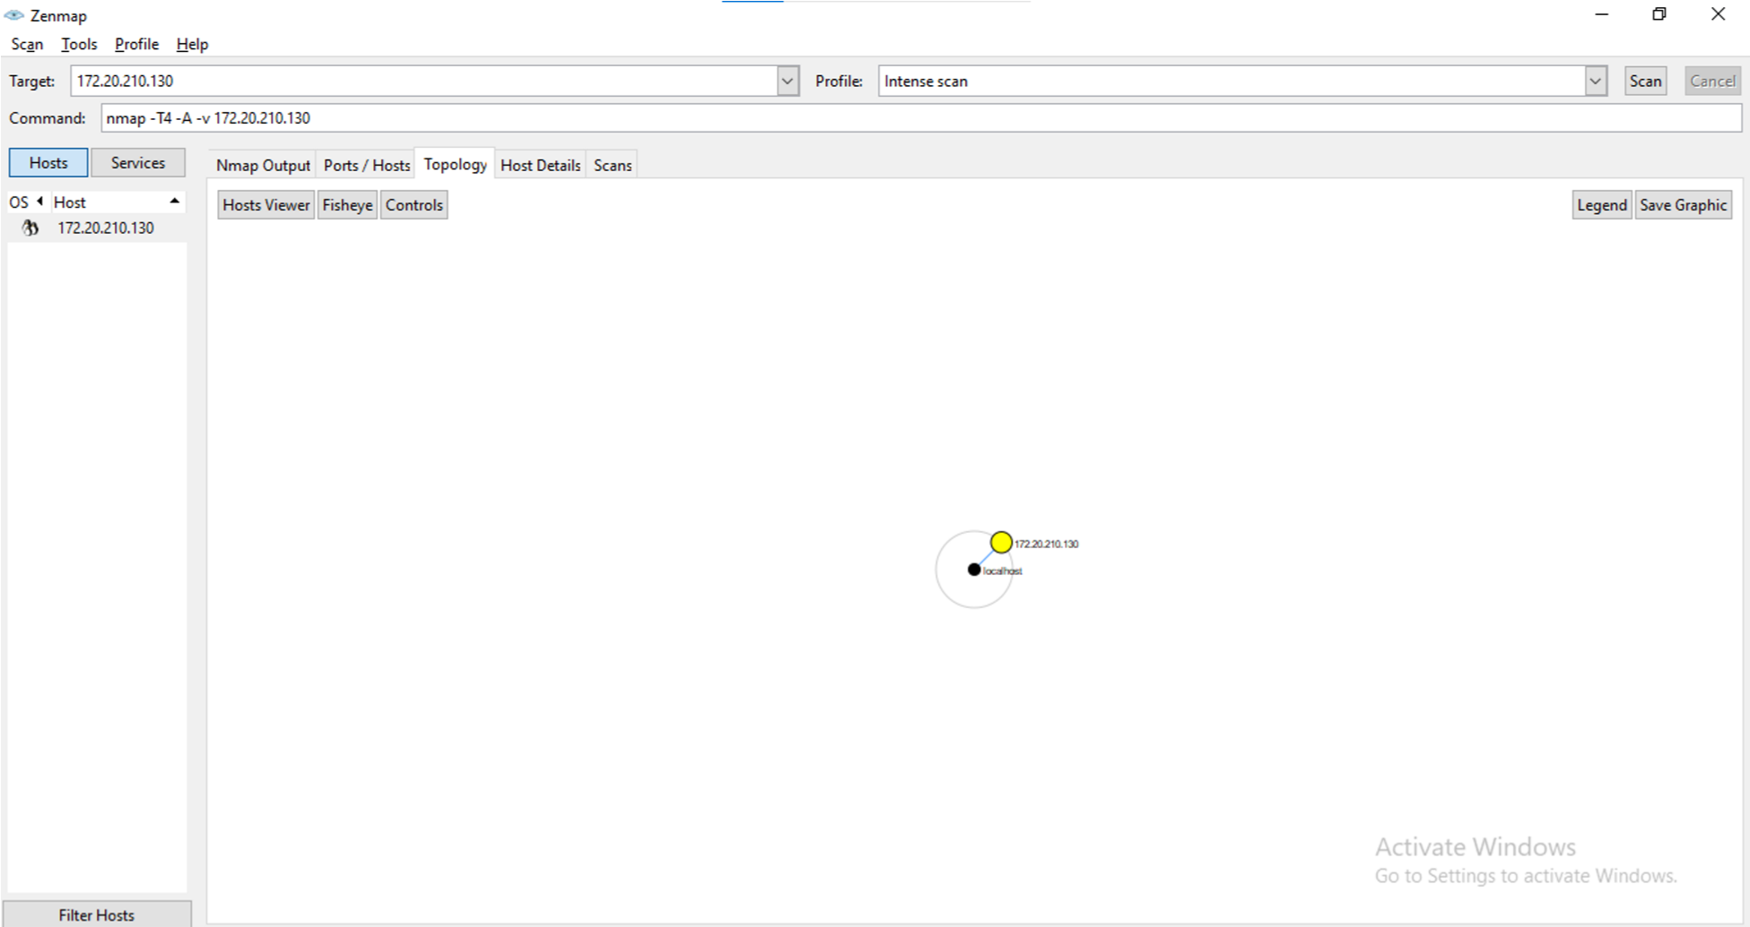

11. Now enter a range of IP Addresses i.e., 172.20.210.1-240

